Practical No. 3
# Name: Thorave Avishkar S.
#Roll No. : 66

Step 1: Extract (Load Data)
- Open Power BI Desktop.
- Click Home > Get Data > Text/CSV.
- Browse to select your sales_data.csv.
- Click Load to import it into Power BI
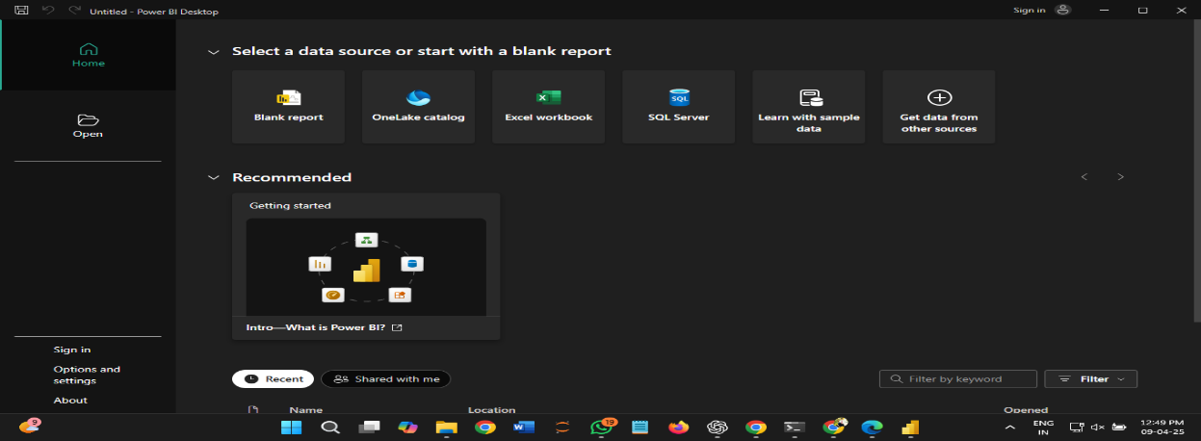
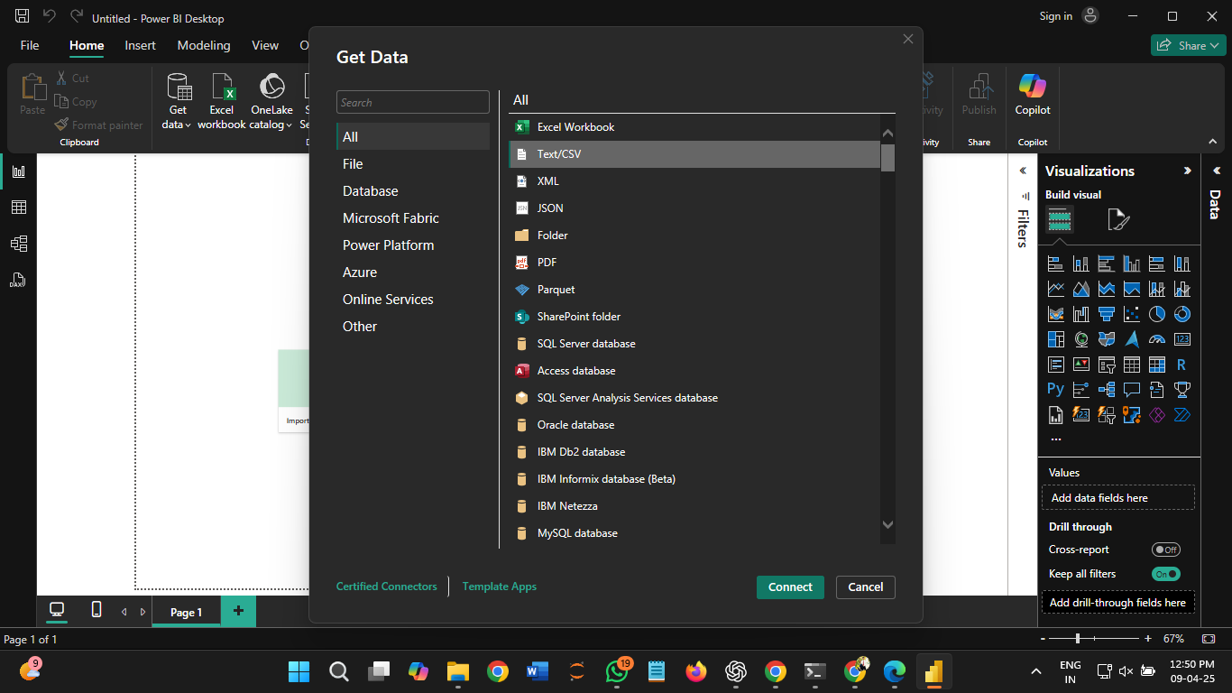

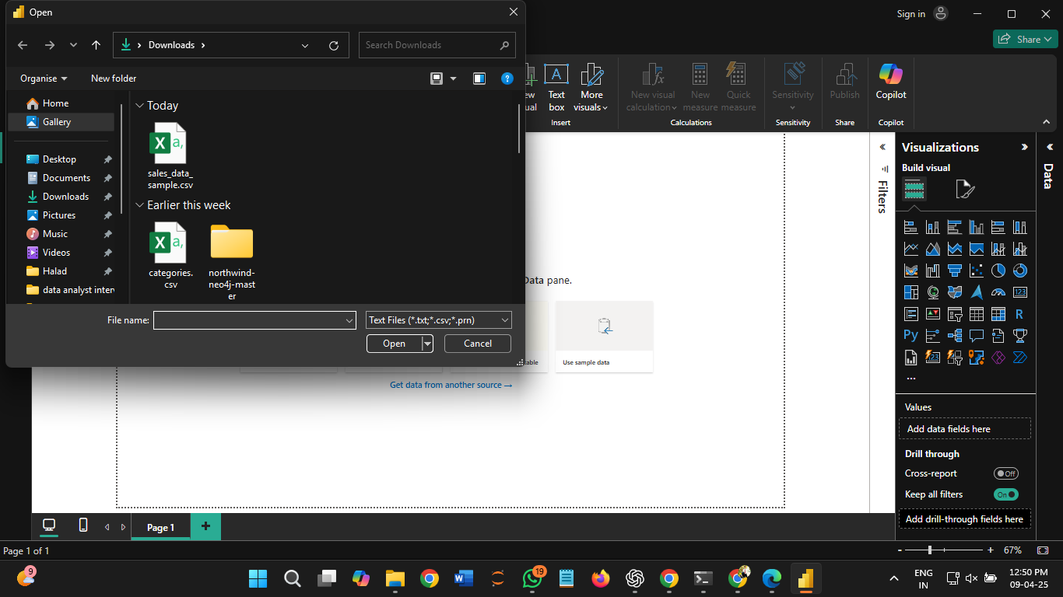

Step 2: Transform (Clean & Modify Data)
- Click Transform Data (Power Query Editor opens).
- Rename Columns (if needed):
Double-click column headers to rename (e.g., Sales Amount → sales).
- Change Data Types:
Right-click column headers → Change Type → Choose appropriate type (e.g., sales to Decimal, date to Date).
- Normalize the Sales Column:
Go to Add Column > Custom Column.
- Enter a name: normalized_sales Click OK – this will create a new normalized column.

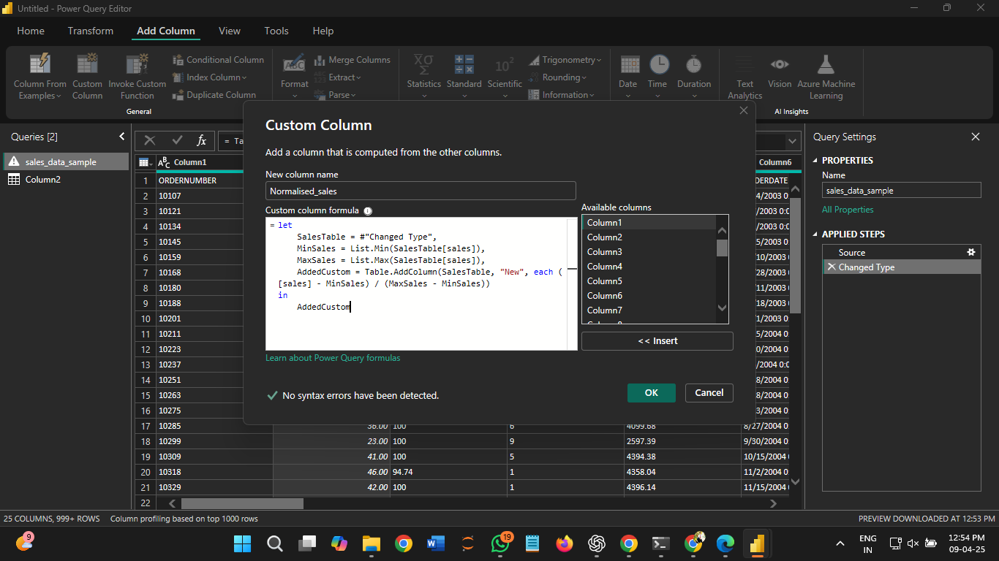
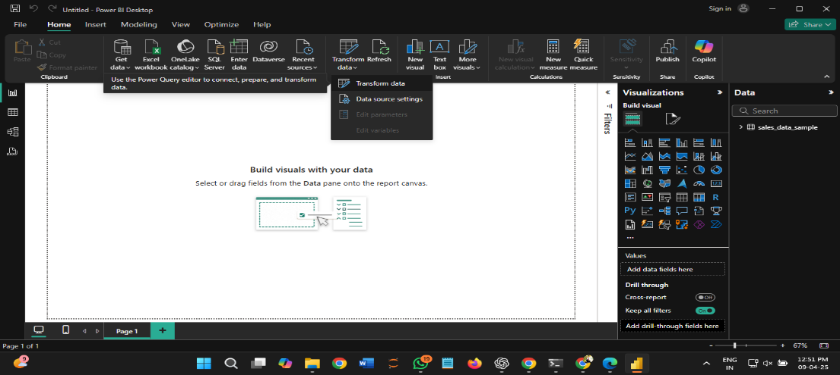
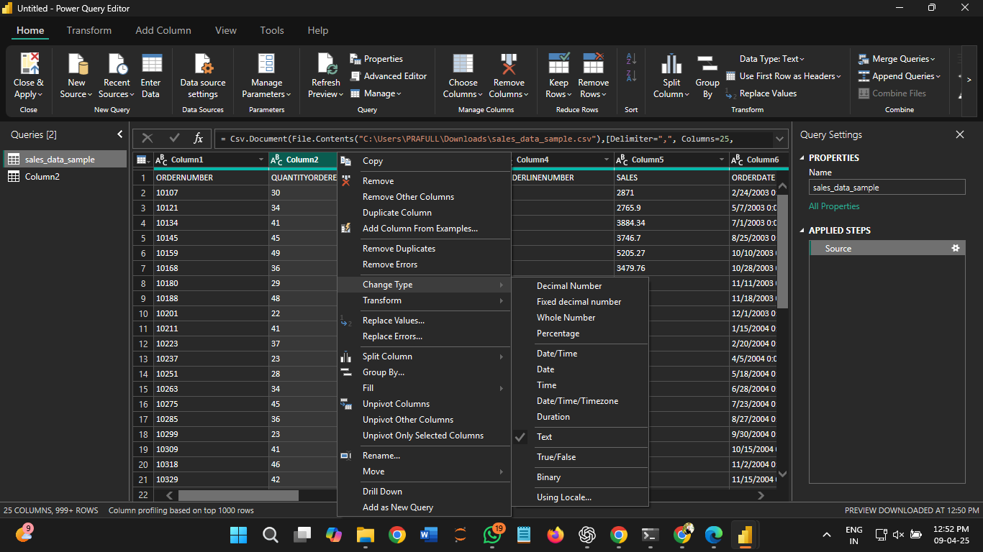
Step 3: Load (Apply to Data Model)
- Click Close & Apply.

